Name: Abrha Gebreslassie, Berhe

Subject: Lab Assignment - 3

**Problem – 1 – Explanation**

The reason for the equals () method to show different results when tested differently is because the ***Liskov Substitution Principle (*LSP*)*** is violated. Even though the “PersonWithJob” IS-A “Person”, its instance cannot substitute instance of the class “Person” because it has an instance variable “salary” while the “Person” class has not. The equals () method in the “PersonWithJob” class expects the “Person” class to have equal salary to return “true” result.

**Problem – 3 – UML Diagram**

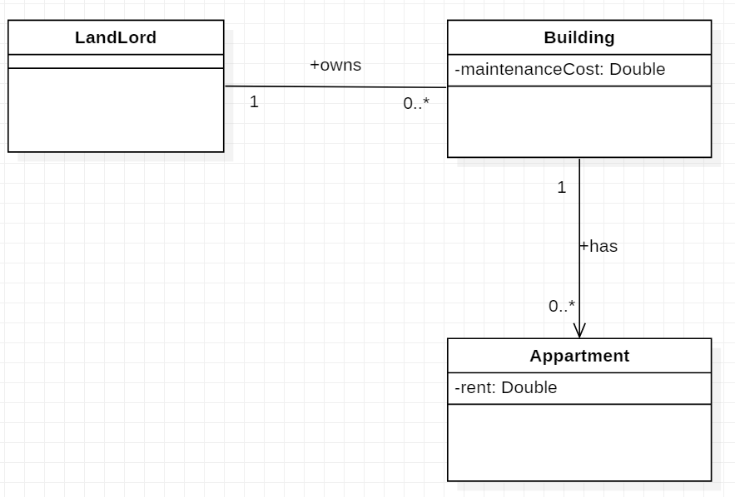

**Problem – 3**

1. **Explanation**

When using inheritance, it may give sense to say Circle is a Cylinder because circle is a cylinder with height Zero. However, the LSP still is violated because it becomes it gives a result Zero when we try to calculate the area of a circle using an instance of Cylinder because the height of circle is Zero. Therefore, it is preferred not to use inheritance here.

1. **UML-Diagram**

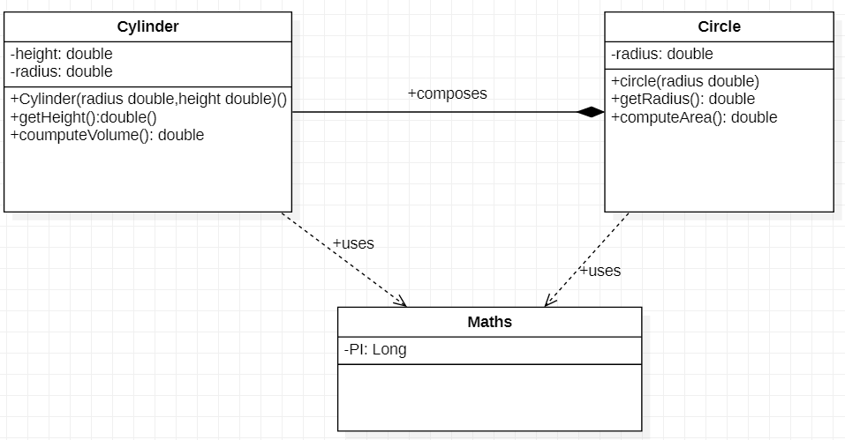

**Problem –4 – UML Diagram**

